From the Ground Up: Odyssey Sealed
Justin Gary
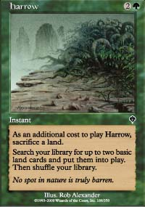
A key card in Invasion Block Limited.
There are few better tests of skill in Magic then analyzing a new Limited format. Invasion Block gave us a remarkably balanced Limited environment that required one to master many skills in order to ensure success. Primarily, Invasion Block was about mana. Powerhouse gold cards in allied and opposing colors put mana fixers such as Harrow and Dream Thrush at a premium. Because of the intensive mana requirements, most decks wanted to run 18 or more mana sources in order to ensure smooth development in the early game. Powerful cards such as Magma Burst and Probe provided an opportunity to turn this dangerously heavy mana supply to a player's advantage in the mid-late game.
As fascinating as Invasion Block Limited was, it is gone for good and Odyssey brings with it new challenges. Without powerful gold cards, Odyssey Limited decks are much more likely to be two colors with more stable mana supplies. In addition, the allied and opposing color considerations of Invasion Limited are non-existent in the new set. In this article, I will attempt to give a first analysis of Odyssey sealed by looking at an actual sealed deck from the prerelease and deciding how to build it. I have always felt that the best way to analyze a new format is to jump right in, so here we go with a card pool played by Steven Terry at the Boston Prerelease:

Black
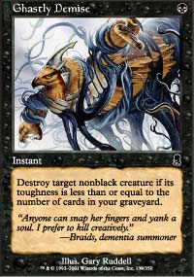
2 Cabal Inquisitor
2 Whispering Shade
1 Filthy Cur
2 Diabolic Tutor
1 Afflict
1 Stalking Bloodsucker
1 Coffin Purge
1 Malevolent Awakening
3 Ghastly Demise
1 Execute
1 Zombie Cannibal

Blue
2 Repel
1 Aether Burst
1 Syncopate
1 Laquatas's Creativity
1 Cephalid Looter
1 Touch of Invisibility
1 Aboshan's Desire
1 Thought Nibbler
1 Unifying Theory

White
3 Cease Fire
1 Patrol Hound
1 Gallantry
1 Pilgrim of Justice
1 Aven Flock
1 Mystic Visionary
1 Pianna, Nomad Captain
1 Confessor
1 Shelter

Green
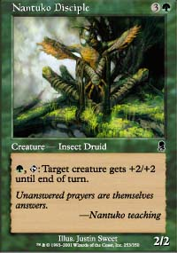
1 Muscle Burst
1 Vivify
1 Beast Attack
1 Springing Tiger
1 Nantuko Disciple
1 Twigwalker
1 Leaf Dancer
1 Werebear
1 Diligent Farmhand
1 Chatter of the Squirrel
1 Moment's Peace
1 Druid's Call
1 Primal Frenzy

Red
1 Seize the Day
1 Recoup
1 Kamahl's Desire
1 Spark Mage
2 Pardic Swordsmith
1 Mad Dog
2 Barbarian Lunatic
1 Pardic Firecat
1 Anarchist
1 Frenetic Ogre
2 Acceptable Losses
1 Thermal Blast
1 Scorching Missile
1 Reckless Charge

Artifact
1 Shadowblood Egg
1 Patchwork Gnomes

Land
2 Timberland Ruins
1 Bog Wreckage
1 Abandoned Outpost

Gold
Sarcatog
And here is the deck that Steve built:
1 Mad Dog
2 Barbarian Lunatic
1 Pardic Firecat
1 Anarchist
1 Frenetic Ogre
1 Springing Tiger
1 Nantuko Disciple
1 Twigwalker
1 Patchwork Gnomes
1 Leaf Dancer
1 Werebear
1 Diligent Farmhand
2 Acceptable Losses
1 Thermal Blast
1 Scorching Missile
1 Reckless Charge
1 Muscle Burst
1 Vivify
1 Beast Attack
1 Chatter of the Squirrel
9 Forest
8 Mountain
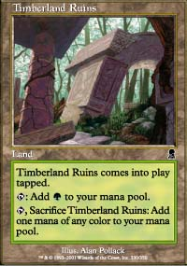
This decklist looks pretty good. Red and green are the only colors with solid creature bases and therefore are the obvious choice to play. Blue and white are pathetic and though black has some very powerful cards, it would never serve as a main color because of the weak creature base (the largest creature aside from the Stalking Bloodsucker is Filthy Cur!). This deck is built to be very aggressive playing out quick, efficient threats and using red burn and green creature enhancing to break through the opponent's defenses. Cards like Scorching Missile and Reckless Charge serve as finishers. This deck has a very solid mana base and though it runs a few weaker cards, it is a fine build. In fact, the deck's mana base is a little too good. This build of the deck fails to utilize the 2 Timberland Ruins available. Timberland Ruins, along with its counterpart in each other color, is a very useful card in an environment where excess lands are often better in the graveyard than in play. 2 Ruins combined with a Diligent Farmhand and a Shadowblood Egg provide for a pretty good base with which to splash a third color. Even though black didn't look good as a base color, some powerful cards make it very appealing to splash.
Both the tutors and the Bloodsucker are appealing, but the double black cost will be prohibitive. Not to worry, though, there are still three (!) Ghastly Demises to work with. Ghastly Demise is a fine removal spell and can provide a more versatile means of punching through in the late game. In addition to being able to add Demise to the main deck, splashing black opens up our sideboarding options by allowing us to side in Execute, which is amazing when it can be played. So here is how I would revise the deck.
1 Mad Dog
2 Barbarian Lunatic
1 Pardic Firecat
1 Springing Tiger
1 Nantuko Disciple
1 Twigwalker
1 Leaf Dancer
1 Werebear
1 Patchwork Gnomes
1 Diligent Farmhand
1 Anarchist
1 Frenetic Ogre
2 Acceptable Losses
1 Thermal Blast
1 Muscle Burst
1 Vivify
1 Beast Attack
1 Shadowblood Egg
2 Ghastly Demise
2 Timberland Ruins
7 Forest
6 Mountain
1 Bog Wreckage
1 Swamp
This deck is a bit less aggressive than Steve's original build, but what it sacrifices in speed and mana consistency, it makes up for in bonus removal. Some of you out there might disagree with these changes. In fact, I hope that many of you do. I chose to use this deck as an example not because it allowed me to correct mistakes in deckbuilding, but because it allows me to show you some different approaches to Odyssey sealed. Some choices are obvious (playing green), but others aren't. Until the Magic community has had more time to play Odyssey sealed, we won't know for sure the relative power of cards within the format and within each deck archetype. I hope to continue this series by looking at other interesting sealed decks that pose difficult deck building questions. If any of you out there have a particularly difficult to build or interesting sealed deck, send it in (jwg@dartmouth.edu) and maybe I'll review it in my next article. And, as always questions and feedback are welcome, but please do not be offended if I can't respond to every email I receive (law school applications take a slightly higher priority than Magic right now). I will do my best to respond to as many letters as I can. See you next time.

